Date: November 7, 2024
To: Weber County Board of County Commissioners
From: Ronna Tidwell
Community Development Department
Agenda Date: November 12, 2024
Subject: Request to Declare Parcel Number 13-119-0019 as Surplus Property
Attachments: A - Aerial Vicinity Map
B - Ownership Plat

_____________________________________________________________________________________

Summary:
A Weber County owned parcel of land, identified as Tax ID #13-119-0019, was acquired by the County through a tax sale process and deed executed in 1985. The parcel is approximately 10’ x 131’, 1310 sf and is located at approximately 2147 N Harrison Blvd, Ogden, UT 84401. See Attachment A for a vicinity map and Attachment B for the County Recorder’s ownership plat map.
The County has been contacted by an adjacent property owner who has asked if the County would consider selling the subject parcel.
Weber County has no intended use for this property; therefore, it is recommended that the parcel be declared as surplus and offered to the adjacent property owner. In order to convey real property, the County Commission must first take action to declare this parcel as surplus property.

Property Description:

13-119-0019

THE SOUTH 10 FEET OF LOT 5, BLOCK 1, BRUMMITT'S ADDITION, OGDEN CITY, WEBER COUNTY, UTAH.
Attachment A
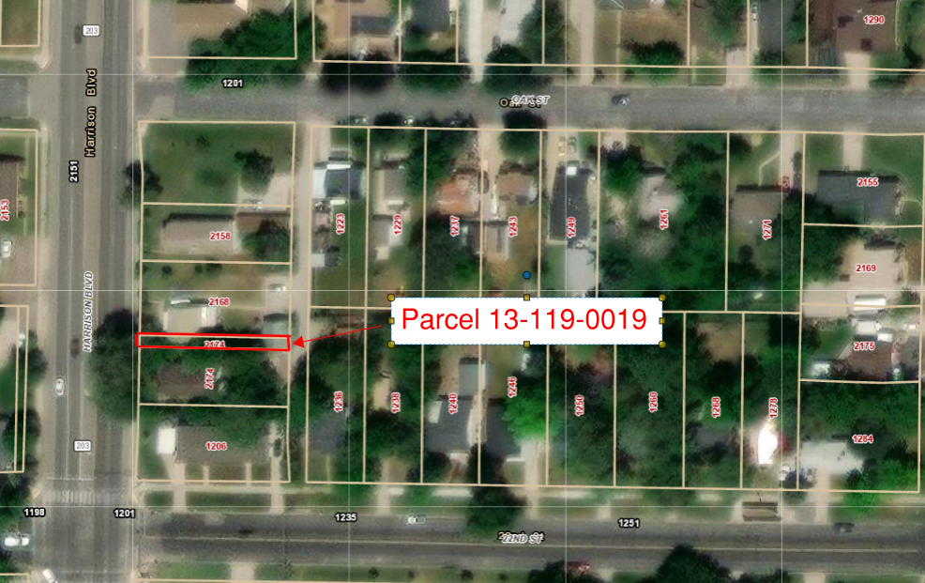

Attachment B
